Comparative Analysis for DataSet_1

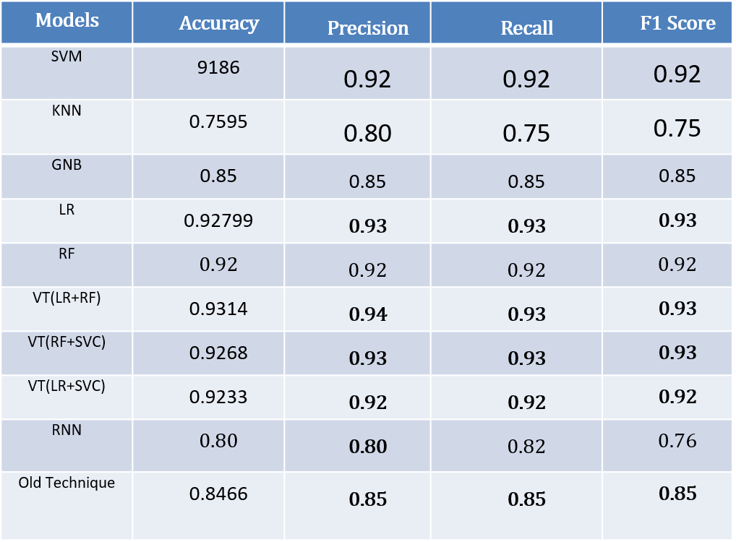

SVM

|  |  |  |  |  |
| --- | --- | --- | --- | --- |
|  | Predicted Class | | | |
| Test Class |  | Positive | Negative | Neutral |
| Positive | 302 | 10 | 4 |
| Negative | 23 | 246 | 4 |
| Neutral | 21 | 8 | 243 |

KNN

|  |  |  |  |  |
| --- | --- | --- | --- | --- |
|  | Predicted Class | | | |
| Test Class |  | Positive | Negative | Neutral |
| Positive | 270 | 0 | 46 |
| Negative | 101 | 146 | 26 |
| Neutral | 29 | 5 | 238 |

GNB

|  |  |  |  |  |
| --- | --- | --- | --- | --- |
|  | Predicted Class | | | |
| Test Class |  | Positive | Negative | Neutral |
| Positive | 249 | 20 | 47 |
| Negative | 13 | 248 | 12 |
| Neutral | 35 | 5 | 232 |

LR

|  |  |  |  |  |
| --- | --- | --- | --- | --- |
|  | Predicted Class | | | |
| Test Class |  | Positive | Negative | Neutral |
| Positive | 303 | 5 | 8 |
| Negative | 16 | 253 | 4 |
| Neutral | 23 | 6 | 243 |

RF

|  |  |  |  |  |
| --- | --- | --- | --- | --- |
|  | Predicted Class | | | |
| Test Class |  | Positive | Negative | Neutral |
| Positive | 289 | 19 | 8 |
| Negative | 12 | 259 | 2 |
| Neutral | 24 | 8 | 240 |

VT(LR+RF)

|  |  |  |  |  |
| --- | --- | --- | --- | --- |
|  | Predicted Class | | | |
| Test Class |  | Positive | Negative | Neutral |
| Positive | 301 | 9 | 6 |
| Negative | 13 | 259 | 1 |
| Neutral | 22 | 8 | 242 |

RF+SVC

|  |  |  |  |  |
| --- | --- | --- | --- | --- |
|  | Predicted Class | | | |
| Test Class |  | Positive | Negative | Neutral |
| Positive | 294 | 13 | 9 |
| Negative | 12 | 257 | 4 |
| Neutral | 16 | 9 | 247 |

LR+SVC

|  |  |  |  |  |
| --- | --- | --- | --- | --- |
|  | Predicted Class | | | |
| Test Class |  | Positive | Negative | Neutral |
| Positive | 296 | 10 | 10 |
| Negative | 13 | 253 | 7 |
| Neutral | 19 | 7 | 246 |

BP

|  |  |  |  |  |
| --- | --- | --- | --- | --- |
|  | Predicted Class | | | |
| Test Class |  | Positive | Negative | Neutral |
| Positive | 263 | 33 | 11 |
| Negative | 33 | 233 | 4 |
| Neutral | 32 | 19 | 233 |

Comparative Analysis for Dataset_2

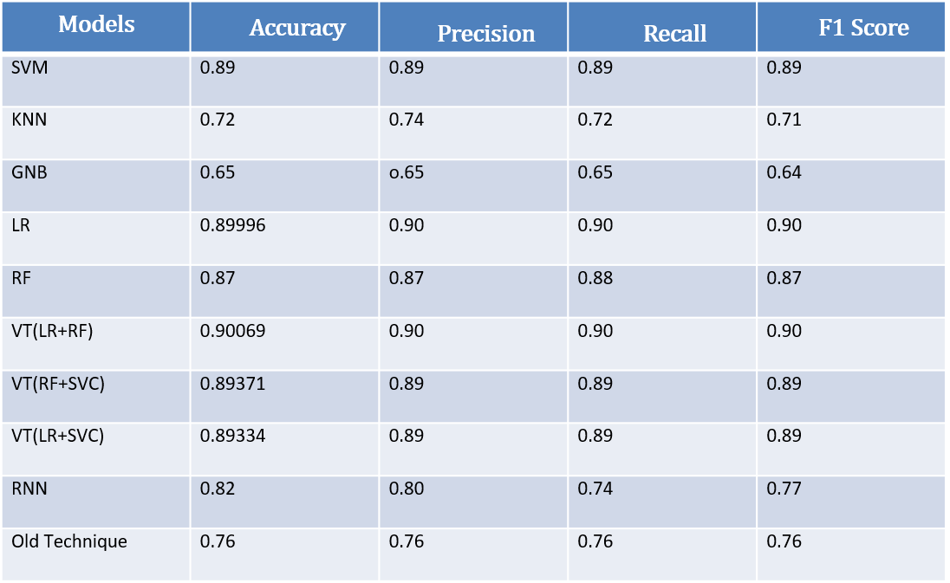

SVM

|  |  |  |  |  |
| --- | --- | --- | --- | --- |
|  | Predicted Class | | | |
| Test Class |  | Positive | Negative | Neutral |
| Positive | 298 | 300 | 272 |
| Negative | 280 | 313 | 284 |
| Neutral | 306 | 344 | 322 |

KNN

|  |  |  |  |  |
| --- | --- | --- | --- | --- |
|  | Predicted Class | | | |
| Test Class |  | Positive | Negative | Neutral |
| Positive | 434 | 211 | 225 |
| Negative | 82 | 671 | 124 |
| Neutral | 32 | 73 | 867 |

GNB

|  |  |  |  |  |
| --- | --- | --- | --- | --- |
|  | Predicted Class | | | |
| Test Class |  | Positive | Negative | Neutral |
| Positive | 499 | 111 | 260 |
| Negative | 114 | 666 | 97 |
| Neutral | 176 | 205 | 591 |

Logistic Regression

|  |  |  |  |  |
| --- | --- | --- | --- | --- |
|  | Predicted Class | | | |
| Test Class |  | Positive | Negative | Neutral |
| Positive | 778 | 49 | 43 |
| Negative | 75 | 787 | 15 |
| Neutral | 51 | 39 | 882 |

RF

|  |  |  |  |  |
| --- | --- | --- | --- | --- |
|  | Predicted Class | | | |
| Test Class |  | Positive | Negative | Neutral |
| Positive | 745 | 66 | 59 |
| Negative | 61 | 797 | 19 |
| Neutral | 98 | 37 | 837 |

VT(LR+RF)

|  |  |  |  |  |
| --- | --- | --- | --- | --- |
|  | Predicted Class | | | |
| Test Class |  | Positive | Negative | Neutral |
| Positive | 780 | 49 | 41 |
| Negative | 59 | 800 | 18 |
| Neutral | 65 | 38 | 869 |

RF+SVC

|  |  |  |  |  |
| --- | --- | --- | --- | --- |
|  | Predicted Class | | | |
| Test Class |  | Positive | Negative | Neutral |
| Positive | 768 | 52 | 50 |
| Negative | 63 | 791 | 23 |
| Neutral | 66 | 35 | 871 |

LR+SVC

|  |  |  |  |  |
| --- | --- | --- | --- | --- |
|  | Predicted Class | | | |
| Test Class |  | Positive | Negative | Neutral |
| Positive | 763 | 56 | 51 |
| Negative | 66 | 789 | 22 |
| Neutral | 55 | 40 | 877 |

BP

|  |  |  |  |  |
| --- | --- | --- | --- | --- |
|  | Predicted Class | | | |
| Test Class |  | Positive | Negative | Neutral |
| Positive | 618 | 160 | 83 |
| Negative | 142 | 691 | 30 |
| Neutral | 124 | 106 | 765 |